**Copyright protected by: :p :v** 

**Anindya Das Antar**

**(Megalomaniac)**

q-2:- could a solar cell be used as a normal diode ?

Both are silicon diodes but the requirements are different..a nominal diode has small area of silicon and hence it generates less amount of power.Whereas it is quite different in solar diode.It has large area of silicon and hence generates considerable amount of power.

Besides we can use solar cell as a diode in dark condition . When there is no light the i-v characteristics of a solar cell is just like nominal diode. When light falls on a solar cell it creates illuminated current and it’s characteristics differ from a nominal diode.

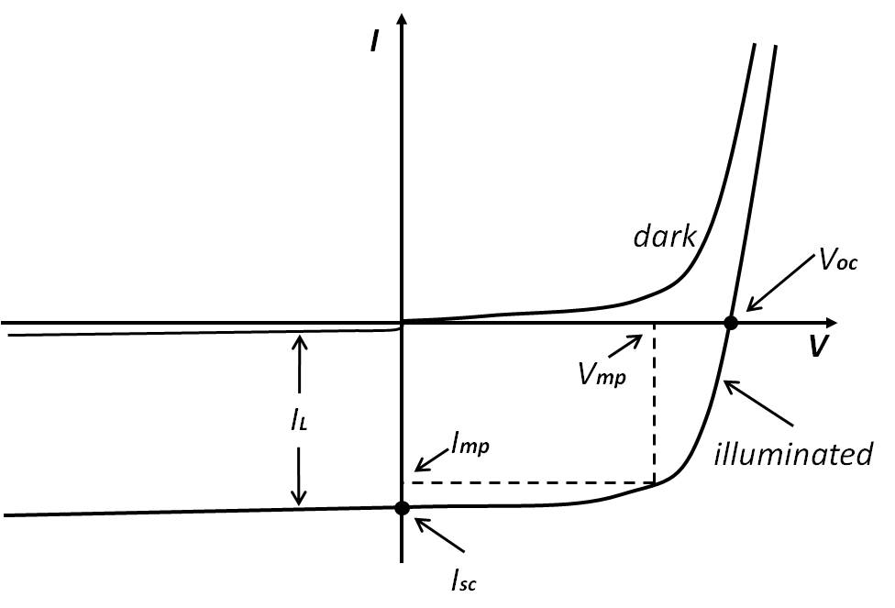

But there are some basic differences between solar cell and a nominal diode:

In solar PV panel, P-N junction diode is used as solar PV cell which absorbs the light and convert light into electricity. But normal diode can not absorb the light.

The solar cell is a pn-junction diode optimized to convert the incident solar radiation to electrical energy. Like wise every diode is optimized for its specific application such as rectifier diodes and zener diodes.

The major difference, however . is the metallization of the two electrodes, the anode and the cathode.

The back side of the solar cell which is normally the anode is completely metallized while the front side electrode is partially metallized in form of metal fingers and buss bars to allow light to pass to the active solar solar cell material and absorbed in the material to generate the photocurrent and at the same time collecting the photocurrent by the metal grid to access electrically the front electrode.

The other main difference is in the doping of the substrate material it is selected to optimize the the open circuit voltage while collecting an appreciable part of the incident radiation by adjusting its thicness. The optimum doping concentration fore silicon is about 10^17/cm^3 and the thicness is about 250 micrometer.

The normal diode is fully metallised from both sides an therefore it is opaque for light.

q-3 :- why it is not better option to design a pyranometer / pyrheliometer using solar cell ?  
  
Pyranometer is an instrument to measure total hemispherical solar radiation(Beam+Diffuse).

A pyrheliometer is used to measure direct solar radiation from the sun and its marginal periphery. To

measure direct solar radiation correctly, its receiving surface must be arranged to be normal to the solar

direction.

Solar cell based pyranometer uses a light-sensitive chip instead of a thermopile. It uses a simple [photodiode](http://www.explainthatstuff.com/how-photoelectric-cells-work.html) (a light-sensing chip) mounted in a sealed housing, with filters and a phosphor above the photodiode restricting the light passing through to the precise part of the spectrum we want to measure.  
though tis type of pyranometers/pyrheliometers are considerably cheaper they some major drawbacks.

The best thermopile pyranometers are designed to respond more or less equally to a substantial band of incoming light wavelengths (this is sometimes described as a flat wavelength response). Lesser, chip-based pyranometers don't do this. Their main drawback is that they don't respond linearly to a broad band of solar radiation but only to a limited range of wavelengths; so while a high-quality pyranometer might measure wavelengths from 280–2800 nanometers, a solar-cell version might respond to wavelengths in a much narrower band from about 300–1100 nanometers (with a peak in the infrared region from around 800-1100nm). But unless you're making really detailed measurements in a laboratory, that may be perfectly fine for your needs.

a semiconductor or silicon pyranometer uses a photodiode (a device that converts light into current) to create an electrical signal from the incoming solar radiation. The disadvantage of the silicon pyranometer is that its spectral sensitivity is limited, which means it simply does not see the whole spectrum of the sun. Not surprisingly, this can result in errors of measurements.

q-5 :- would any avalanche process within solar cell increase it's efficiency?

The electron avalanche effect was first found inside solar cells some four years ago at the Los Alamos National Laboratories, albeit the measurements were inconclusive to establish whether or not the effect was real.

The testing rig used by the TU Delft researchers is made out of lead selenide nanocrystals and does indeed seem to present the electron avalanche effect.

Avalanche breakdown

is characterized by a strong exponential increase of the

reverse current in the voltage range starting at 13 up

to 18 V .

The solar cell prototype created by them involves the use of semiconducting materials made of nanocrystals. Traditional semiconducting materials used to manufacture solar cells generate one electron per absorbed photon. However, in certain semiconductor nanocrystals one photon of light can release two or three electrons, which translates in a maximum conversion efficiency of 44 percent. As it turns out, such solar cells are also significantly cheaper to manufacture than those made through the current production process.

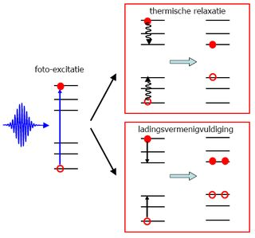

Figure Avalanche process within solar cell

q -4 :- to absorb the full spectrum of sun ,why a single material of lower bandgap is not efficient compared to tandem solar cell??

why a tandem cell offers a boost in efficiency, one has to look at how different solar cell materials react to incoming light. Tandem cells are created using more than one junction in a cell.

Sunlight is made up of a wide variety of energies, from ultraviolet light and visible light, which have a higher level of energy, to infrared light, which is lower energy. A solar cell uses a semiconducting material like silicon to absorb the sun’s light and convert it to electrical power. A semiconductor has a special property called a [bandgap](http://en.wikipedia.org/wiki/Band_gap) that allows it to both absorb light and extract the energy from the light as electricity.

Most solar panels have a single absorbing material, such as silicon. There is a tradeoff when choosing the bandgap of the absorbing material. With a smaller bandgap, a wider range of energy from the sun can be absorbed, generating more current. However, a smaller bandgap also means a smaller voltage at which the electrical current can be extracted. Because electrical power is voltage multiplied by current, there is a sweet spot. Too small of a bandgap and the solar cell produces a large current but small voltage and the opposite for too large of a bandgap.

Tandems minimize this tradeoff. When using two absorbers, each absorber specializes in a portion of the solar spectrum rather than a single absorber responsible for the entire solar spectrum. The first absorber is responsible for all visible and ultraviolet particles of light, or photons. Underneath it, the second absorber is responsible for the infrared photons. Having these specialized absorbers minimizes the loss of energy that occurs when sunlight is lost as heat, rather than electric current.

We use the metal-halide perovskite as the first absorber in our tandem to capture the ultraviolet and visible light and silicon as the second absorber to capture the infrared light.

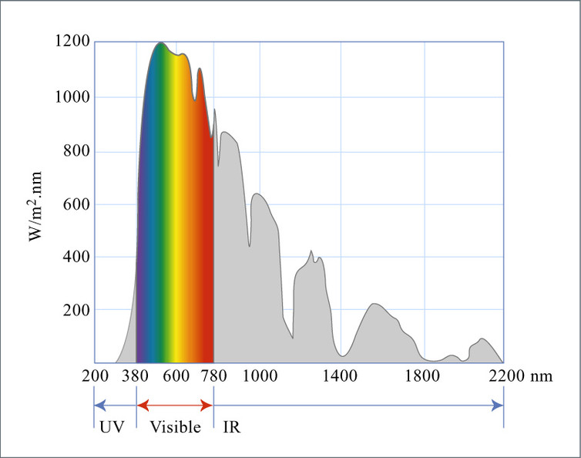

q-6 :- propose a microprocessor based sun tracking system? would a solar cell act as a good sensor for this system ?

photo detection range 300-1100nm

uv range 800-1100 nm so high chance to get mixture

q-1 :- why solar module rated for 12v is usually designed for 18v?

**Solar panel temperature**  
Now let’s discuss the effect temperature has on solar cells.  
Solar cells need to be kept as cool as possible because the solar cell’s efficiency drops by about 10% for every 20°C rise in temperature, so at 45°C you can expect 10% less power output. On the plus side, because solar panels love to be cool, at 5°C you can expect 10% more power than its rated output.  
  
The power loss is caused by a decrease in cell voltage at higher temperatures. Let’s look at the diagram below. Ignore the dotted lines showing the current flow (amps) at various light levels, we’ll discuss that later, just look at the top line showing how maximum voltage decreases at higher temperatures of the solar cells.  
  
At 50°C the optimum voltage is about 15 volts and at 75°C it’s only about 11 volts. Now you might think those temperatures are higher than you would get on a normal sunny day but solar panels are designed to absorb as much sunlight as possible and more sun equals more heat. Even on a relatively cool day when air temperature is about 10°C the solar cell will be at about 30°C, so on a typical warm sunny day the temperatures of the solar cells reach about 60°C.  
That’s why 12v solar panels are designed to supply about 18 volts. A lot of the time the solar panel is hot and is only generating about 15 volts or less.  
The actual temperature sensitivity depends on the type of solar panel but the bottom line is you can’t expect to get maximum power from a hot solar panel.

